Atria Institute of Technology



**Department of Information Science and Engineering**

# Big Data Analytics (18CS72)

**Assignment-1**

**SUBMITTED BY**

Name: PARVEEN SIDDIQA

USN: 1AT20IS057

Section: ISE ‘2’

Submission Date:

**Course Handling Faculty Name:**

Dr. K S Ananda Kumar

Associate Professor Dept of ISE, Atria IT.

## Table of contents

|  |  |
| --- | --- |
| **Sl. No** | **Description** |
| 1 | 1. create an **EC2 Linux** instance in AWS Cloud /Any cloud  INSTANCE NAME - **YOUR NAME**  INSTANCE TYPE - t2.micro/any other also. key pair name- your name storage - 10 GB  Take the screenshot of instance running status  Mention the private IP address and Public IP address.  (Execute this program/concept and take a screenshot of the output) |
| 2 | Execute the basic Linux commands/ simple program on the instance  (Execute this program and take a screenshot of the output) |
| 3 | Create the **GitHub** Account with your credentials, Same things stored in public repository in Github. Share the assignment in github link. |

**Note:**

1. Minimum 10 Screenshots with proper explanation
2. Minimum no of pages – 10
3. Submit your Assignment soft copy (Word & PDF) to anandakumar.ks@atria.edu. **Subject Line in mail:** Student_Name_USN_BDA_Assignment1
4. Share your assignment Github link in Assignment Document.
5. Submit Assignment on or before **27th Dec 2023.**

**Instance Creation-01**

**Virtual Machine Instance created in Microsoft Azure**

Step:1 Creating a Virtual Machine

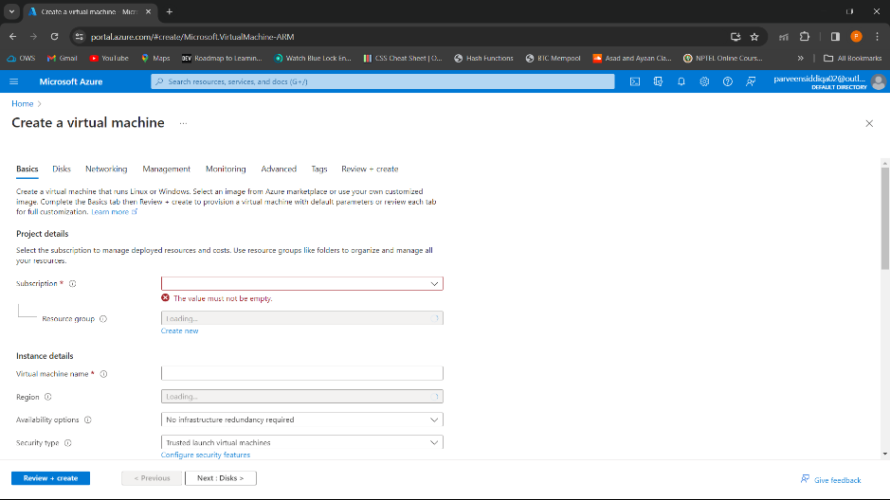

Step:2 Filling the basic details

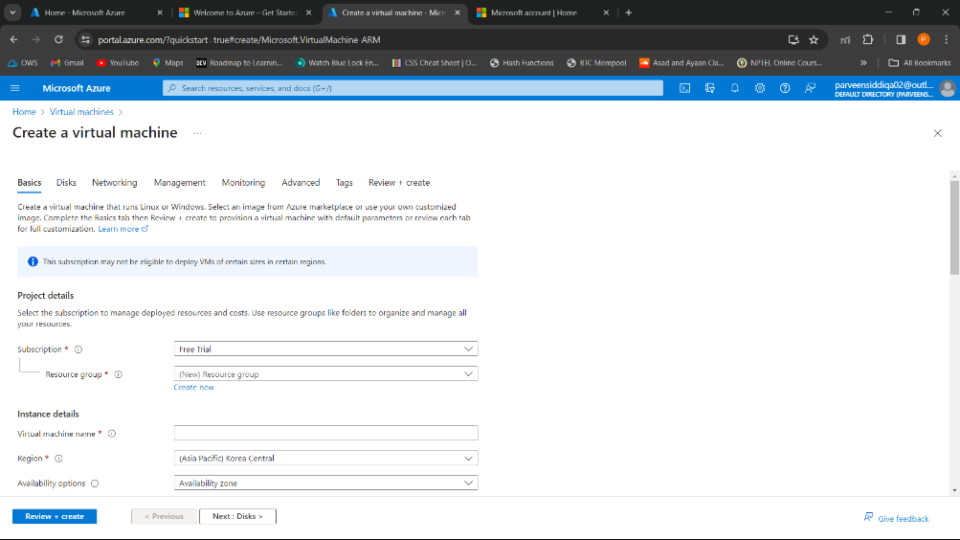

Step:3 Network Interface

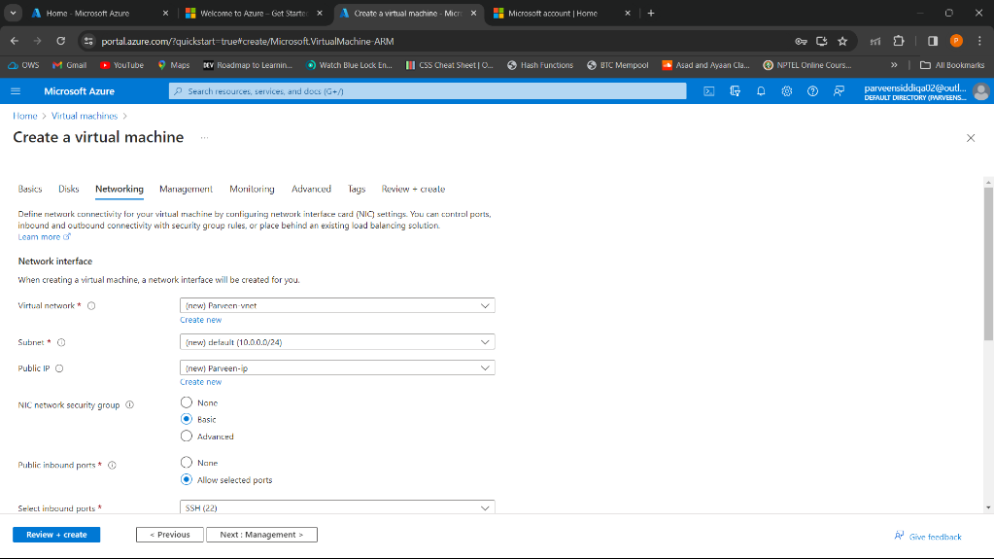

Step:4 Configuring manage option for the VM

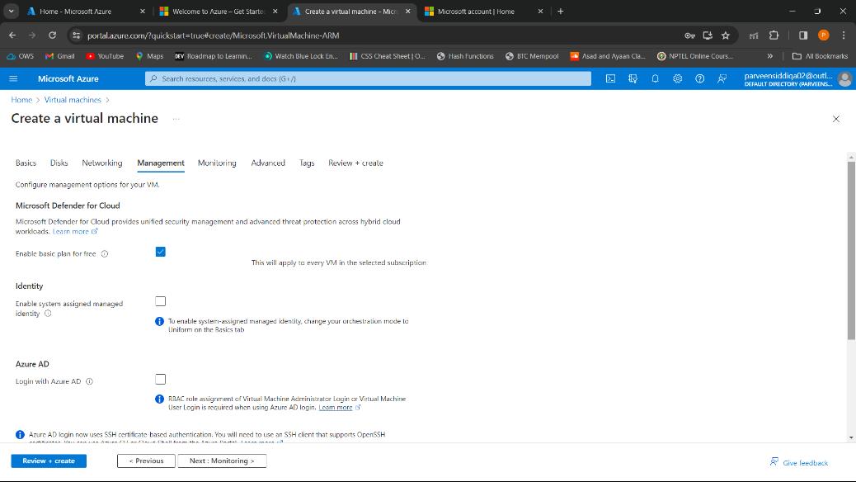

Step:5 Configuring monitoring option for the VM

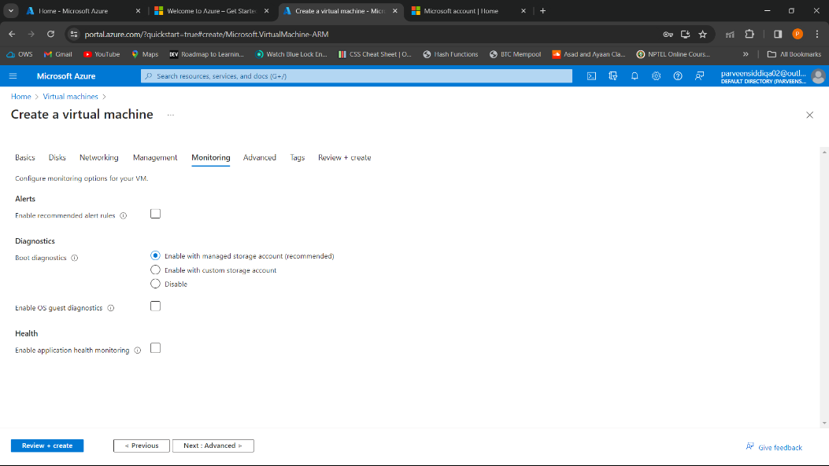

Step:6 Add additional configuration, agents, scripts via virtual machine extensions.

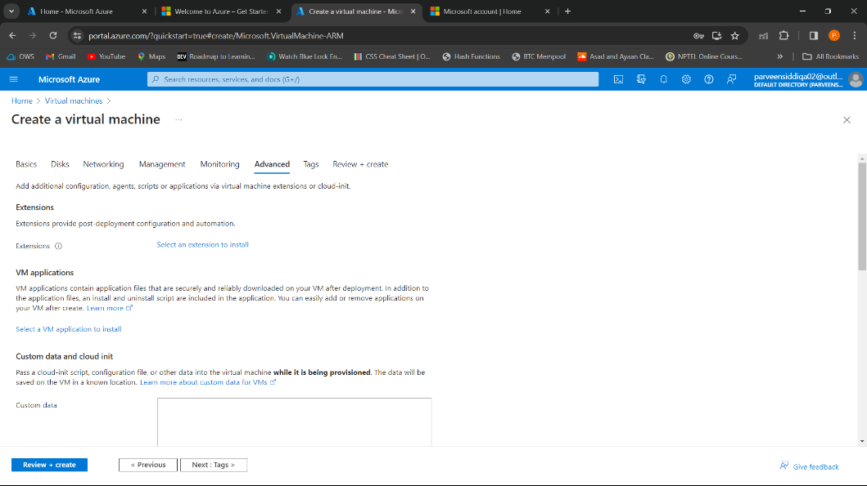

Step:7 creating tags. Tags are the name value pair.

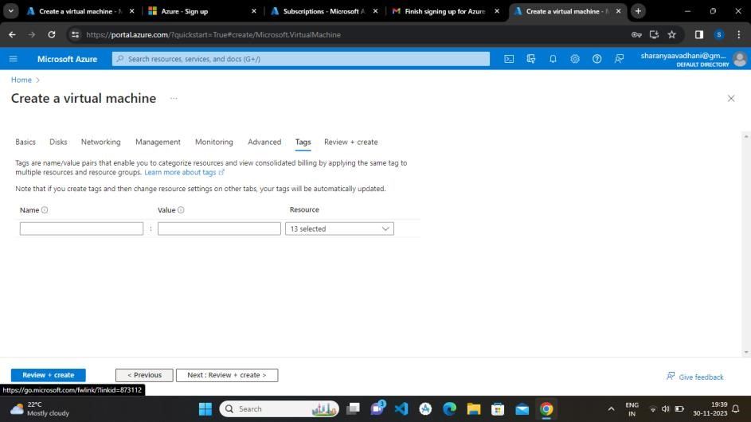

Microsoft Azure Dashboard

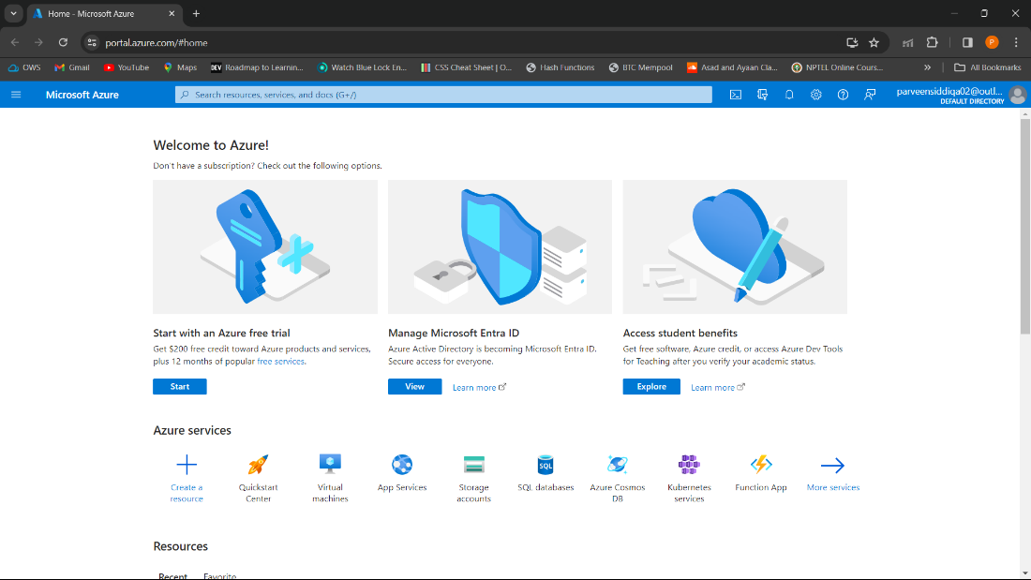

Virtual Machine Details

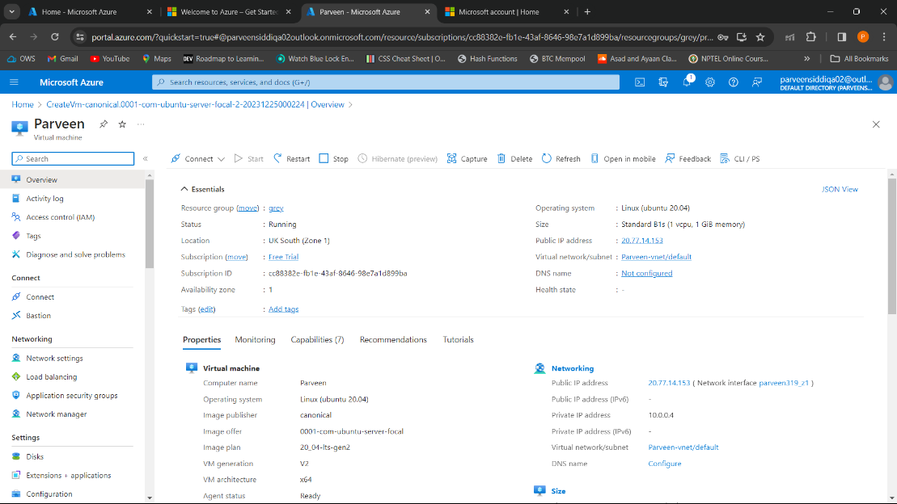

# Running sample Program on Linux Instance

Commands executed are:

1. mkdir
2. cd
3. pwd
4. ls
5. echo
6. rmdir

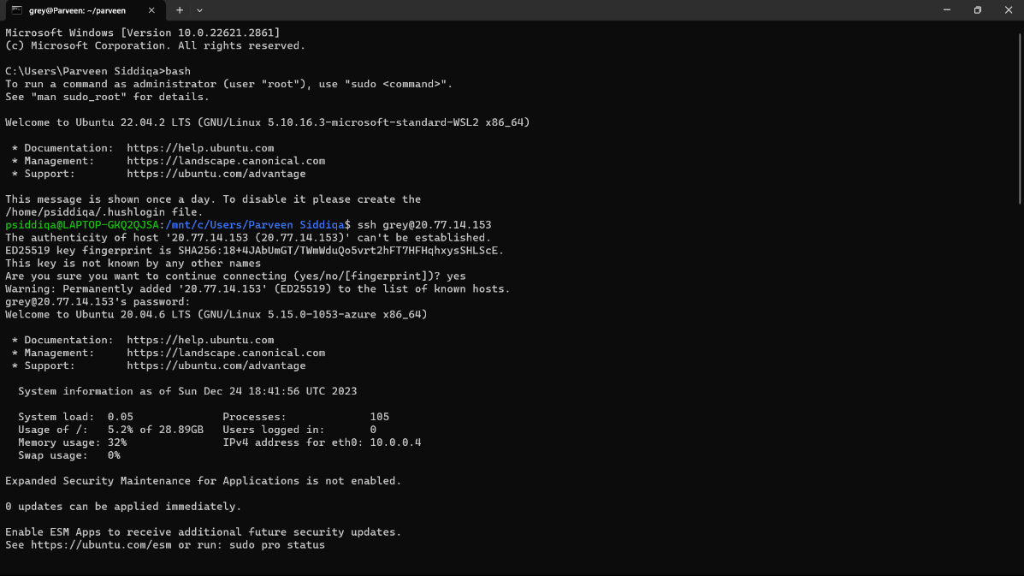

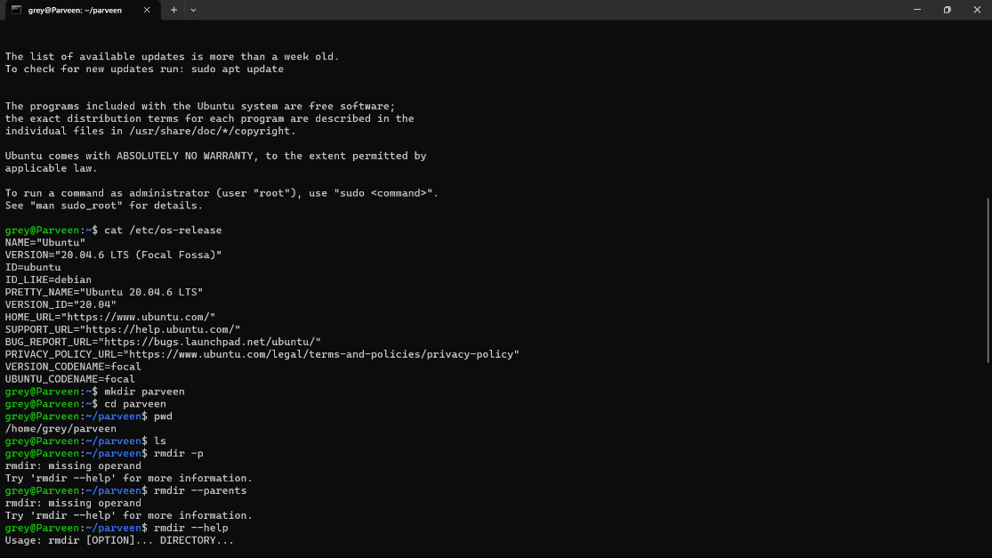

* 1. ls: The ls command lists the files in the current directory. It is one of the most basic and simple command.
  2. Mkdir: create one or more directories specified by the Directory parameter.
  3. Pwd: prints the full name (the full path) of current/working directory.
  4. Echo: The echo command in Linux is a built-in command that allows users to display lines of text or strings that are passed as arguments.
  5. Rmdir: removes the directory, specified by the Directory parameter, from the system.
  6. Cd: can be used to change into a subdirectory, move back into the parent directory, move all the way back to the root directory or move to any given directory.

**Assignment GitHub Link**

<https://github.com/SharanyaAvadhani/BDA-Assignment>